DATA PREPROCESSING IN A DATA SET

AIM
To identify and handle missing values in a dataset and normalize numerical data using the StandardScaler function from the Scikit-learn library.

ALGORITHM
- Import the Pandas library and StandardScaler from Scikit-learn.
- Load the dataset from the CSV file data.csv.
- Display the first five rows of the original dataset using head().
- Check for missing values in each column using isnull().sum().
- Replace missing numerical values with the mean of their respective columns using fillna().
- Select the numerical columns Hours_Studied, Attendance, Assignments, and Marks.
- Create a StandardScaler object.
- Normalize the selected columns using fit_transform().
- Convert the normalized data into a Pandas DataFrame with the original column names.
- Display the first five rows of the normalized dataset.

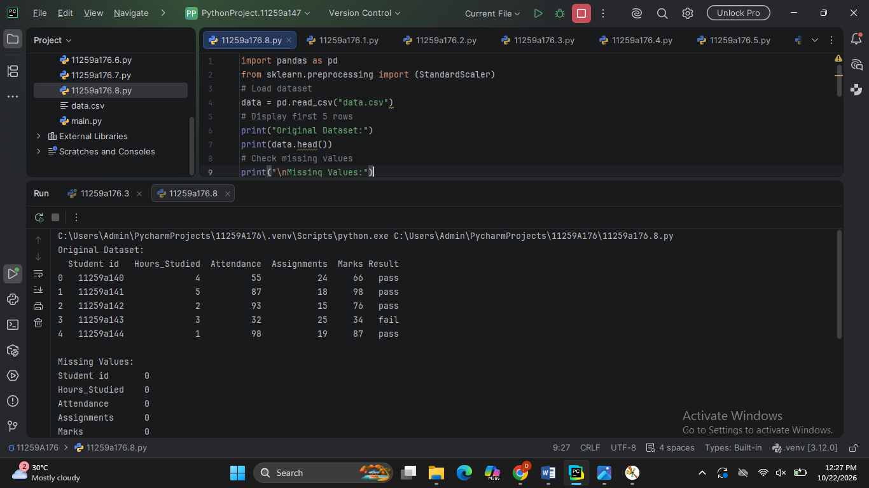
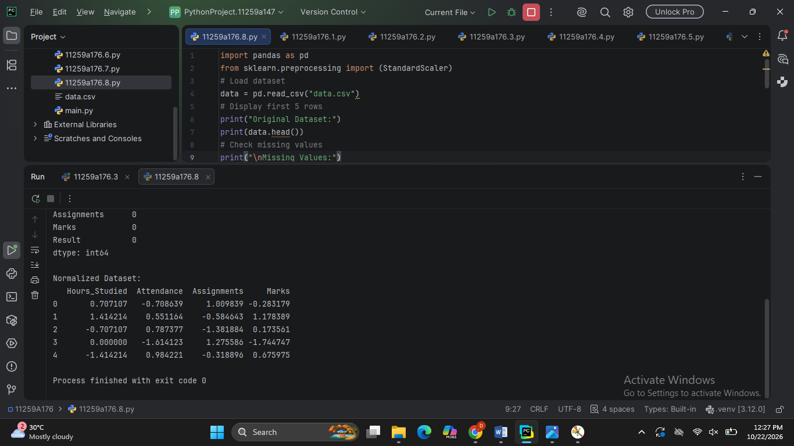

RESULT
The dataset was successfully loaded, missing numerical values were handled using column means, and the selected numerical features were normalized using StandardScaler. The normalized features have a mean approximately equal to 0 and a standard deviation approximately equal to 1.

